Jana Small Finance Bank Ltd.

Application Number | 102760000000699
Details of Borrower’s & their family members & their Occupations |  | Name | Relation |  | Age (DOB) |  | Qualification | Earning (Yes/No) | Approx. Income
 |  | Mrs. Radhika | Wife |  | 35 |  | Graduate | None | Not Applicable
 |  | Ms. Sahithi | Daughter |  | 17 |  | 12th Pass | Studying | Not Applicable
Initiated address (Employment/Business) |  | Initiated Address |  |  |  |  | Visiting Address
 |  | 8138 46 1 padmashalipuram Mailardevpally Near Jagan Oil Mill Rangareddy 500005. |  |  |  |  | 8138 46 1 padmashalipuram Mailardevpally Near Jagan Oil Mill Rangareddy 500005.
Borrower’s Profile
 |  | Applicant |  | Mr. Sambharapu Narender (10/10/1986)
 |  | Co-applicant |  | Mrs. Radhika (01/07/1988)
Residence Details & Stability at Current Residence | He resides in owned house located at initiated address Hyderabad and having an area of 50 Sq. Yards and current market value of Rs. 65Lacs approx this property on the name of applicant and gets monthly rental income of Rs. 7000/- approx
Residence ownership | Self-owned
Name of Firm (employer/business) | M/s Shri Gents Tailors Kaja Buttons
Designation of Borrower/ownership type of business | Proprietorship Concern
If Partnership or Pvt. Ltd.  Firm details of  partner’s/share holders | Shareholding Details:
 |  | Name of the Shareholder | Relation with Main Applicant |  |  | Designation | % of Shareholding | Coming into Loan Structure | Functions Handled
Employment/  Business Details & Stability  Business premises details | He operates his business from owned residence cum business premises located at initiated address Hyderabad and having an area of 50 Sq. Yards and current market value of Rs.65Lacs approx. This property on the name of applicant.

Business Profile  /Employment job profile along with previous business/employment details | He is engaged in the business of providing service of Gents tailor business. Under this business, he deals in providing gents tailoring/stitching services like shirts pants, khaja buttons, etc. based on customer requirement. He has all are individual and regular customers from surrounding areas. He has purchase required material from individual and regular suppliers located at Hyderabad locations. His receipts and payment transactions are 80% cash and 20% online payment basis. He does monthly Shirts & Pants (Pair) 50-55 pairs approx and per pair charges are of Rs. 1000/- approx. Khaja buttons of Rs.35000/- approx.
- Average Stock Maintained:  - Working Hours: | Not Applicable  His business timings are not fixed
Employee Details (to be filled for Self Employed Profile): |  |  | No. of Employees | Salary Per Month Per Employee |  |  | Status of Employee |  | No. of Labours | Wages Per Month/ per Day |  | Status of Labour
 |  |  | Not Applicable | Not Applicable |  |  | Not Applicable |  | Not Applicable | Not Applicable |  | Not Applicable
Current monthly Salary (to be filled in salaried income profile) | Mode of salary paid by employer – Cash/ Bank credit
 |  | Last 3 months Salary |  |  | Net Salary as per salary slip/certificate |  |  | Net Salary as per bank credit |  |  | Date of Credit
 |  | NA |  |  | NA |  |  | NA |  |  | NA
 |  | NA |  |  | NA |  |  | NA |  |  | NA
 |  | NA |  |  | NA |  |  | NA |  |  | NA
Other Source of Income (If any)
 |  | Type of Income |  |  |  | Amount |  |  |  | Remarks (Pls. Specify)
 |  | Gets monthly rental income of Rs.7000/- approx. |  |  |  | Rental income |  |  |  | Not Applicable

Specific for Cash Salaried Profile

To be filled in for Cash Salaried profile:-

Did the PD agent met the employer (Y/N) (Name of the employer &  mobile number) | NA
Does the employer maintain the  attendance register (Y/N) | NA
If yes, is the name of the borrower reflecting in the attendance register (Y/N) & for how many months (try to check last 6 months attendance  register) | NA
If no, then do reference checks for employment confirmation with other employees working in the same firm. Minimum 2 references to be obtain. (Name & mobile number of the reference people to  be documented) | NA
Neighbour two reference checks to confirm applicant’s employer information is correct. (name & contact number along with  feedback to be documented) | NA
Does the employer maintain any salary register or any salary paid receipt/voucher or any other documentary proof for salary being  paid to the borrower (Y/N) | NA
If yes, verify the salary paid to the borrower and capture photos in the  PD report | NA
If no, then do reference checks with other employees working in the same firm for salary confirmation. Minimum 2 references to be obtained. (Name & mobile number of the reference people to be  documented). | NA
Any variation in the salary paid amount as per salary certificate & as per salary register verified during  the visit. | NA
Does the employer has GST number? (Y/N). If yes, Try to collect GST of the employer. | NA

Main Business, Products and End use of the same

Tailoring services.

Clients | No. of Fixed Clients : Individual regular  Credit Period : Not Applicable  Cash-Cheque Proportion : 80% cash and 20% online payment basis
 |  | Name (top 3  Clients) |  | Contact Details |  | Location |  | Ref. Check
 |  | M/s. Yadagiri readymade garments |  | 8121196002 |  | Kattedhan Ts |  | Positive
 |  | Mr. Suresh |  | 8919265619 |  | Shamshabad ts |  | Positive
Vendors | No. of Fixed Vendor : Individual regular  Credit Period : Not Applicable  Cash-Cheque Proportion : 80% cash and 20% online payment basis
 |  | Name (top 3  clients) | Contact Details |  | Location |  | Ref. Check
 |  | Not Applicable | Not Applicable |  | Not Applicable |  | Not Applicable
TPC Check | Individual / Knowing Feedback on Feedback on Business Address Contact No Since Borrower Business Name  Nearby Not  business Same area Provided 5 Positive Positive  person

Income Assessment |  | Last 3 months | Sales | % age net profit margin |  | GST paid (in Rupees)
 |  | NA | NA | NA |  | NA
 |  | NA | NA | NA |  | NA
 |  | NA | NA | NA |  | NA
 |  | Particulars |  | Amount (approx.)
 |  | Total Monthly Sales / Revenue |  | 85,000.00
 |  | Less: Monthly Business Expenses |  | 25,500.00
 |  | Net Business Income |  | 59,500.00
 |  | Less: Current Obligations |  | 28,320.00
 |  | Less: Family Expenses |  | 15,000.00
 |  | Net Disposable Income |  | 16,180.00
Annual Sales :- Rs.10.20 lakhs approx
Annual GST paid :-NA Annual Gross profit :- NA
Annual Net profit :-Rs.7.14 lakhs approx
Specific for Contractor Profile | To be filled in for Contractor (Resi cum office) profile:-
 |  | How many contracts completed in last 6  months |  |  | NA
 |  | In what mode, payment is getting against  these contracts. |  |  | NA
 |  | Document name of client, mobile number, type of contract & contract value in PD  report |  |  | NA
 |  | Randomly call 2 to 3 clients to verify the contract details and document the feedback in the PD report along with details of the client called for  confirmation. |  |  | NA
 |  | Neighbour reference checks (minimum 2 people) details with name & contact details to be captured in the PD report |  |  | NA
 |  | Stability or vintage in the same line of  business |  |  | NA
 |  | Direct contractor or doing sub-contracting  work |  |  | NA
 |  | Advance amount paid to workers |  |  | NA
Level of Activity & Stocks along with Observation | - Residential cum business setup seen at the time of visit.  - We observe business setup activity name board business related machines etc at the time of visit.
Details of Property to be | Collateral Address :- Initiated address Hyderabad

Mortgaged
 |  | Area |  |  |  | 50 Sq. Yards
 |  | Agreement value (in lakhs) |  |  |  | 50 Sq. Yards
 |  | Actual Purchase cost (in Lakhs) |  |  |  | 50 Sq. Yards
 |  | Market Value (in Lakhs) |  |  |  | 50 Sq. Yards
 |  | OCR (in lakhs) |  |  |  | 50 Sq. Yards
 |  | OCR paid till date (in Lakhs) |  |  |  | 50 Sq. Yards
 |  | Source of OCR |  |  |  | 50 Sq. Yards
End use of loan
 |  | HL Purchase |  |  |  | NA
 |  | HL Repair or Renovation |  |  |  | NA
 |  | HL Construction |  |  |  | NA
 |  | HL Plot + Construction |  |  |  | NA
 |  | Working Capital |  |  |  | NA
 |  | Asset acquisition and expansion |  |  |  | NA
 |  | Market Development and growth |  |  |  | NA
 |  | Debt Management and Financial efficiency |  |  |  | NA
 |  | BT and TOP-UP |  |  |  | Yes
Other Asset Details (Including properties, vehicles, investments etc.) | Asset Details :  All Immovable properties held that is Residential, Commercial, Land, Plot and any fixed structure:
 |  | Type of Asset |  |  |  | Approx. value (in lakhs)
 |  | Properties (Flat, Individual House, Commercial, Agri land, vacant residential land, etc.) |  |  |  | None
 |  | Life insurance |  |  |  | None
 |  | Medical insurance |  |  |  | None
 |  | SIP |  |  |  | None
 |  | FD |  |  |  | None
 |  | Vehicle |  |  |  | Bike
 |  | Others |  |  |  | None
Loan Details
 |  | Name of Bank | Type of Loan | Loan Amount | O/S Balance (in Lakhs) | EMI | Tenor | MOB | EMI Paid Bank
 |  | JM  Finance | HL | 20 | Not Provided | 28320 | 240 | 24 | SBI Bank

Banking Details
 |  | Bank Name |  | Branch Name |  | Account Type |  | Open Since (Year)
 |  | SBI Bank |  | Kattedhan |  | Savings A/C |  | 15
Loan Amount Required & End Use
 |  | Loan Amount |  |  |  | He required loan amount of Rs. 28Lacs approx
 |  | End Use of Loan (Amount & Detailed End Use) |  |  |  | BT of HL in JM finance and Top-up for business expansion purpose
Existing Relation with this lender Bank/FI | No  Not Applicable
Documents seen during the PD
 |  | Document Category | Document Name |  | Document Type |  | Remarks
 |  | KYC Documents | PAN Card |  | Scan Image |  | ARLPN4648R (10/10/1986)
 |  | Business Ownership Documents | Shop Act License |  | Scan Image |  | Aadhar card verified
 |  | Income & Expense Records | ITRs |  | Scan Image |  | ITRs AY 2024-25 with gross recipets of Rs. 33,64,900/- and net profit of Rs. 4,95,000 (27/03/2025)
 |  | Income & Expense Records | ITRs |  | Scan Image |  | ITRs AY 2023-24 with gross recipets of Rs. 20,08,000/- and net profit of Rs. 4,80,930/- (27/03/2025)
 |  | Business Ownership Documents | Shop Act License |  | Scan Image |  | Labour department registration certificate and Regd no.  SEA/RSN/ALO/SH/0721550/2023  and date of issued on 11/10/2023 (With initiated address)
 |  | Other Documents | Electricity Bills |  | Original |  | Electricity bill provided at the time of visit
 |  | Income & Expense Records | Bank Statements |  | Scan Image |  | SBI saving account bank statement for the period from 01/06/2024 to 24//6/2025 with closing balance of Rs. 137.72/- as on 24/05/2025
 |  | Income & Expense Records | Sales Invoices & Purchase Bills |  | Original |  | Few income records provided at the time of visit
Interviewer’s Comments along with the explanations to credit comments (with brief summary report) | Comforts:  - Initiated address is applicant residence cum business premise address and he was met at the banker initiated address during the visit.  - Residential cum business setup seen at the time of visit.  - Business name board seen at the time of visit.  - He has provided his PAN Card Aadhar Card last 2 years itrs with financials bank statement labour department registration certificate electricity bill etc at the time of visit  - We observe business setup activity name board business related machines etc at the time of visit.

- He has provided few kacha income records during the visit.
- We have seen 3 sewing machines at the initiated address during the visit.
- Business related stock was seen during the visit.
- TPC confirmed about applicant and his business.

Discomforts:
- Residence cum business premise seen during the visit.
- No customer activity was seen during the visit.
- We observed applicant has recently and on the same date filed both years of ITRs i.e. on 27-03-2025.
- Applicant has not provided renewal license during the visit.
- We have not seen QR code scanner at the business premise during the visit.
- We observed high turnover filing in the provided ITR.

Note: As per business calculations we estimated his monthly cash flow.
PD Status  (Positive/Negative/Refer) | Positive (Subject to above concerns)
Interview details
 |  | Interviewer’s Name | Visit Date and Time
 |  | Saideep D | 31 May, 2025 At 17:27
Geo Tag details | Enclosed:  Latitude: 17.3083449, Longitude: 78.4355572

Photographs:

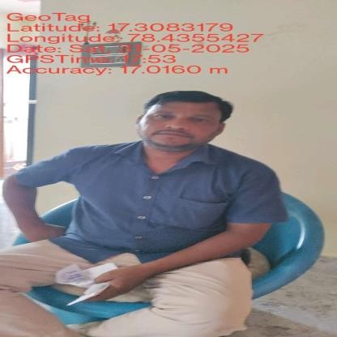 | 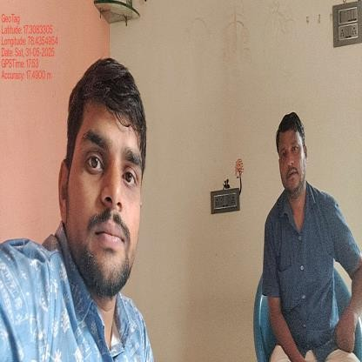 | 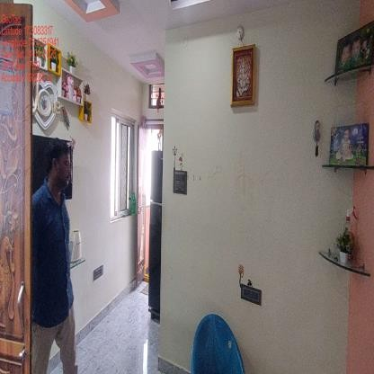

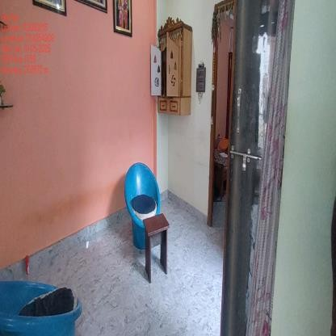 | 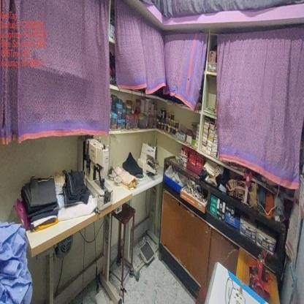 | 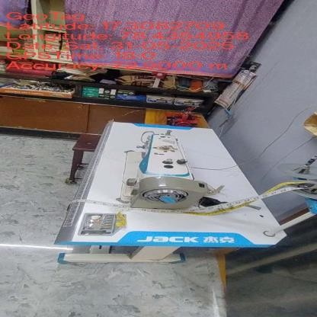
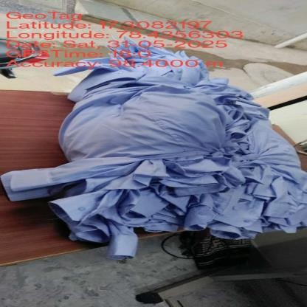 | 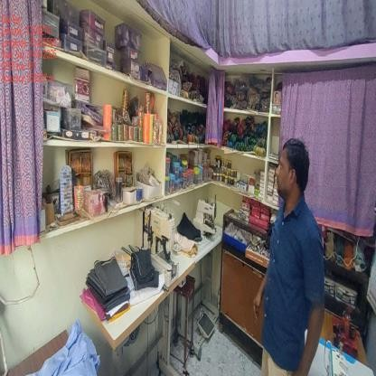 | 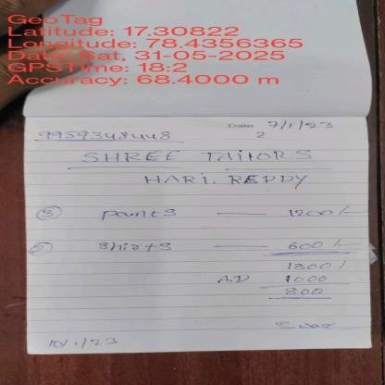
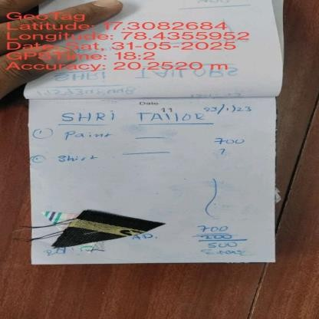 | 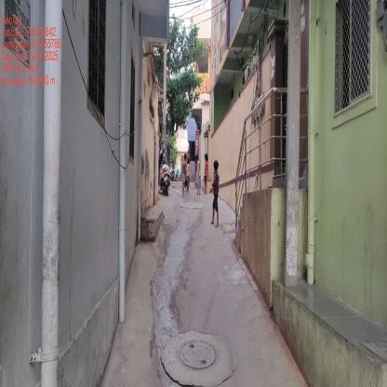 | 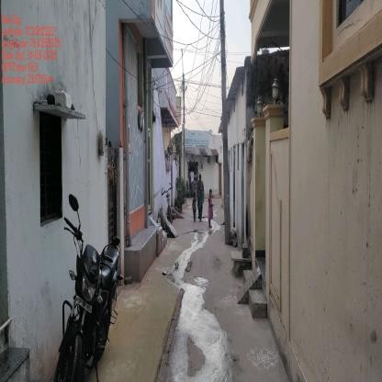
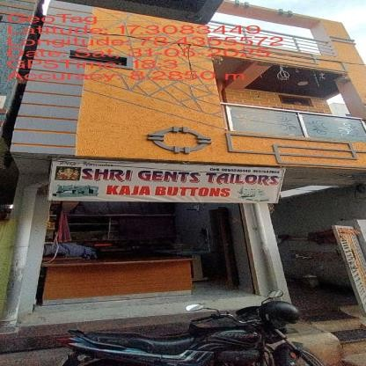 | 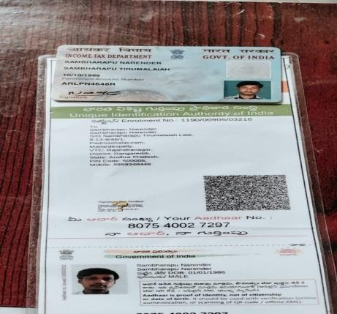 | 

Disclaimer:

This report (including any attachments) has been prepared on the basis of information provided by the person contacted. Jana Small Finance Bank Ltd. will be solely responsible for any actions taken on this report and any liabilities directly or indirectly accruing from such actions. Veeraraghavan & Co. will not be held liable in any case.


